<NAME><student ID>
Week 4 – Lab exercises

Task 4.1

- : Assume that data has the value 10. List the actions the computer executes when it runs the following code.
cout<<“Output 0”<<endl; if (data < 15)
{

cout<<“Output 1”<<endl;

}

else

cout<<“Output 2”<<endl; cout<<“Output 3”;
Sequence | Action | Note
1 | cout is used to print ‘Output 0’ on screen
2 | Evaluates the expression (condition of if) data < 15 | Condition is true.
3
4

- : Assume that data has the value 20. List the actions the computer executes when it runs the following code.
cout<<“Output 0”<<endl; if (data < 15)
cout<<“Output 1”;

else

cout<<“Output 2”;

cout<<“Output 3”;

Sequence | Action | Note
1 | Use the cout with the text ‘Output 0’
2
3
4

c). Give the corresponding snapshots of memory after the following set of statements is executed (explain the execution step by step).
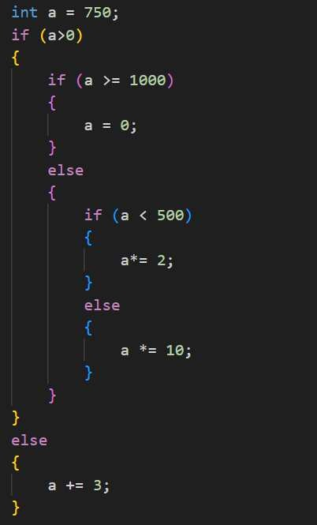

Sequence | Action | Notes or Value of ‘a’

1

2

3

4

5

Add new rows as necessary.

Task 4.2
Write a C++ Program that reads two integers and displays the biggest number.

Source code

Screenshot

Task 4.3

Write a C++ Program that reads 3 marks of a student namely M1, M2, and M3. The student is to be declared as “Pass” only if the student has scored more than or equal to 60 in all subjects and the average is above 65.

Source code

Screenshot

Task 4.4

Write a C++ program that takes an integer score as input and outputs the corresponding grade. The grading system is as follows:
80-100: HD

70-79: D

60-69: C

50-59: P

0-49: F

Source code

Screenshot

